Homework 7 Probability

Name __________________________

Question 1: Probability, Part I
0/24 points
Below is a table listing the probabilities of three binary random variables. In the empty table cells, fill in the correct values for each marginal or conditional probability. Your answers will be evaluated to 4 decimal places, so you may find it easier to enter answers as expressions such as
0.14*0.08/2. The grader will evaluate these expressions maintaining full floating point precision.

NOTE: The numbers on this table and the ones you actually solve in the homework may be very different. Please do a screenshot of your correct answers and paste them in this document if they are different.

X₀ | X₁ | X₂ | P(X₀,X₁,X₂)
0 | 0 | 0 | 0.080
1 | 0 | 0 | 0.220
0 | 1 | 0 | 0.100
1 | 1 | 0 | 0.040
0 | 0 | 1 | 0.080
1 | 0 | 1 | 0.160
0 | 1 | 1 | 0.220
1 | 1 | 1 | 0.100

Expression | Value
P(X₀ = 1, X₁ = 0, X₂ = 1)
P(X₀ = 0, X₁ = 1)
P(X₂ = 0)
P(X₁ = 0 | X₀ = 1)
P(X₀ = 1, X₁ = 0 | X₂ = 1)
P(X₀ = 1 | X₁ = 0, X₂ = 1)

Question 2: Probability, Part II
0.0/24.0 points
You are given the prior distribution P(X), and two conditional distributions P(Y|X) and P(Z|Y) as below (you are also given the fact that Z is independent from X given Y). All variables are binary variables. Compute the table of their joint distribution based on the chain rule. Your answers will be evaluated to 4 decimal places, so you may find it easier to enter answers as expressions such as 0.14*0.08/2. The grader will evaluate these expressions maintaining full floating point precision.

NOTE: The numbers on this table and the ones you actually solve in the homework may be very different. Please do a screenshot of your correct answers and paste them in this document if they are different.

X | Y | P(X,Y)
0 | 0
0 | 1
1 | 0
1 | 1

X | Y | Z | P(X, Y, Z)
0 | 0 | 0
1 | 0 | 0 | 0.21
0 | 1 | 0 | 0.07
1 | 1 | 0
0 | 0 | 1 | 0.06
1 | 0 | 1
0 | 1 | 1 | 0.28
1 | 1 | 1

Question 3: Probability, Part III
0.0/16.0 points
For the following four subparts, you are given three joint probability distribution tables. For each distribution, please identify if the given independence / conditional independence assumption is true or false (type 'true' or 'false'). For your convenience, we have also provided some marginal and conditional probability distribution tables that could assist you in solving this problem. Note that you must get all sections right to receive credit for this problem; incomplete submissions will be marked as incorrect.

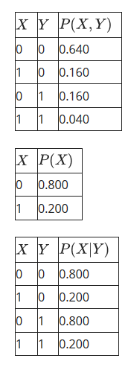
X is independent from Y.
True
False

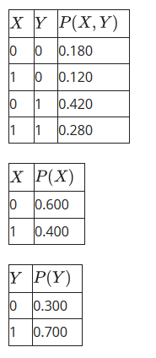
X is independent from Y.
True
False

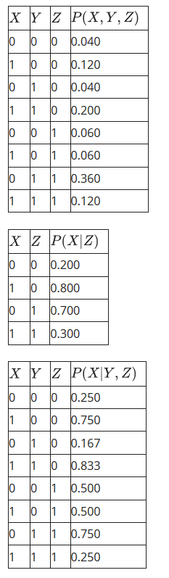
X is independent from Y given Z.
True
False

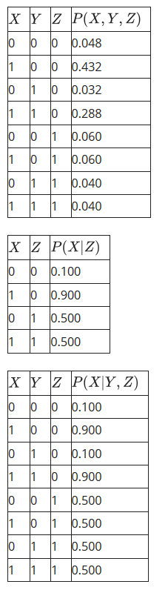
X is independent from Y given Z.
True
False

HMMs, Part I
0.0/18.0 points

NOTE: The numbers on this table and the ones you actually solve in the homework may be very different. Please do a screenshot of your correct answers and paste them in this document if they are different.
Consider the HMM shown below.
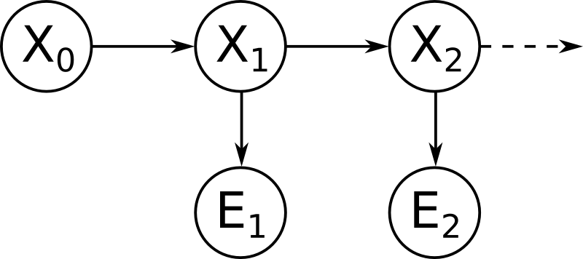
The prior probability P(X₀), dynamics model P(X_{t+1} | X_{t}), and sensor model P(E_{t} | X_{t}) are as follows:
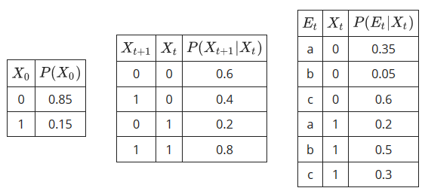
We perform a first dynamics update, and fill in the resulting belief distribution B’(X₁).
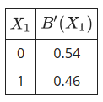
We incorporate the evidence E₁ = c. We fill in the evidence-weighted distribution P(E₁ = c | X₁)B’(X₁), and the (normalized) belief distribution B(X₁).
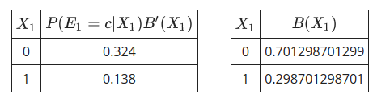
You get to perform the second dynamics update. Fill in the resulting belief distribution B’(X₂).
X₂ | B’(X₂)
0
1

Now incorporate the evidence E₂ = a. Fill in the evidence-weighted distribution P(E₂ = a | X₂)B’(X₂), and the (normalized) belief distribution B(X₂).
X₂ | P(E₂ = a | X₂)B’(X₂)
0
1

X₂ | B(X₂)
0
1

HMMs, Part II
0.0/18.0 points

NOTE: The numbers on this table and the ones you actually solve in the homework may be very different. Please do a screenshot of your correct answers and paste them in this document if they are different.
Consider the same HMM.
The prior probability P(X₀), dynamics model P(X_{t+1} | X_{t}), and sensor model P(E_{t} | X_{t}) are as follows:
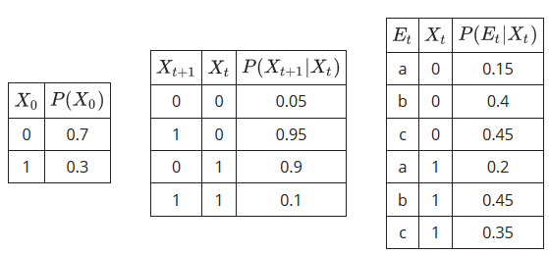
In this question we'll assume the sensor is broken and we get no more evidence readings. We are forced to rely on dynamics updates only going forward. In the limit as t ⟶ ∞, our belief about X_{t} should converge to a stationary distribution
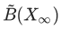
defined as follows:
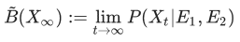
for all values in the domain of X.
In the case of this problem, we can write these relations as a set of linear equations of the form
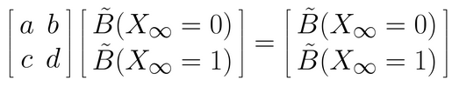
In the spaces below, fill in the coefficients of the linear system. The system you have written has many solutions (consider (0,0), for example), but to get a probability distribution we want the solution that sums to one. Fill in your solution in the table below. (Hint: to check your answer, you can also write some code and run till convergence.)
coefficient | value
a

b

c

d

X∞ | B(X∞)
0

1

